Activity: Sludge gas and biosolids—putting waste to work (Years 9 and 10)
  - Cleaning up sewage
Victorian Curriculum F–10 links:
Levels 9 and 10
Geography
Geographical Knowledge
Environmental change and management
Environmental, economic and technological factors that influence environmental change and human responses to its management
Science
Science Understanding
Science as a Human Endeavour
The values and needs of contemporary society can influence the focus of scientific research
Earth and space sciences
Global systems, including the carbon cycle, rely on interactions involving the atmosphere, biosphere, hydrosphere and lithosphere

Students investigate how materials traditionally thought of as waste products, can be used to improve efficiency, lower costs and decrease the carbon footprint of sewage treatment. This activity focuses on the benefits of biogas production as a renewable energy source.

Duration
Two period sessions

Activity steps
- For an overview of how Melbourne Water’s Eastern and Western Treatment Plants use biogas produced through the treatment process to meet most of the plants’ electricity needs, visit:
- Energy

- Western Treatment Plant:
Biosolids
Sewage treatment process
- Students work in groups and use the internet to research the following questions:
- What is biogas?
- What are anaerobic, aerobic and facultative bacteria and how do they get their energy?
- How do bacteria contribute to the production of biogas?
- How can biogas be used?
- What are the environmental advantages of using biogas?
- How is biogas made and collected at the plant they are visiting?
- How does it differ from the process at the other plant?
- Groups prepare a presentation to argue a case for collecting the gas produced during sewage treatment on economic and environmental grounds. Appoint students to the board of directors of a sewage authority and have groups of students make presentations for the board to decide the most compelling case.
- Discuss the need for sustainability and the measures taken by Melbourne Water to reduce their plants’ carbon footprints and make them more sustainable.

Extension activity
In groups, students investigate other sustainability projects undertaken by Melbourne Water such as the recycling of biosolids and water and their possible uses, and then present their findings to the class.

Teacher background
Anaerobic digestion of solids to produce biogas
Bacteria types:
- aerobic—requires oxygen for respiration so live in oxic environments
- anaerobic—does not require oxygen for respiration, but uses other substances such as nitrates, sulphates and sulphur. Anaerobic bacteria die in the presence of oxygen and thus exist in an anoxic environment.
- facultative—live in either oxic or anoxic environments and can use either aerobic or anaerobic respiration, depending on their environment.
Biogas is a mixture principally of methane with carbon dioxide and traces of other gases such as ammonia and hydrogen sulphide. It is produced by anaerobic bacteria as they break down the organic matter in sewage in the absence of oxygen. Oxygen, present in the sewage initially, is removed by aerobic oxygen-loving bacteria and, when this is complete, the anaerobic bacteria can convert complex organic compounds into methane and carbon dioxide.
Several kinds of anaerobic bacteria feed on the raw sewage, with the by-products of digestion of one type of bacteria providing the food for another bacterial population. The first stage involves liquefaction during which acid-producing bacteria (acidogens) secrete enzymes, which convert long-chain fats, proteins and starches into simpler substances, especially low molecular weight organic acids like acetic acid and alcohols. In the second stage, known as gasification, methane-producing bacteria (methanogens) use enzymes to break down the acids into methane and carbon dioxide.
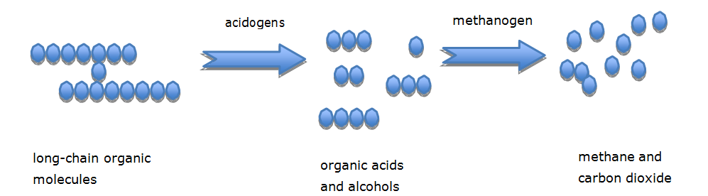
Figure 1 Sequence of anaerobic bacteria in the production of biogas

Victorian Curriculum and Assessment Authority (VCAA) <http://victoriancurriculum.vcaa.vic.edu.au/> Accessed 14 August 2016.

